Displaying Basemaps in QGIS
Version 2.18.16
March, 2018

This document is intended to show the various ways that basemaps can be displayed in QGIS

1. Open Layers plugin:

This was the first QGIS plugin to provide links to basemaps. However, it has the disadvantage that it forces the map window to use the WGS / Pseudo Mercator (EPSG: 3857) coordinate system. Most users have abandoned it in favor of the QuickMapServices plugin.

https://gis.stackexchange.com/questions/166937/adding-openlayers-basemap-to-a-qgis-project-changes-the-crs-to-wgs-84-pseudo-m

2. QuickMapServices (QMS) plugin:

a. QMS accommodates any coordinate system, which is a huge advantage over the Open Layers Plugin.
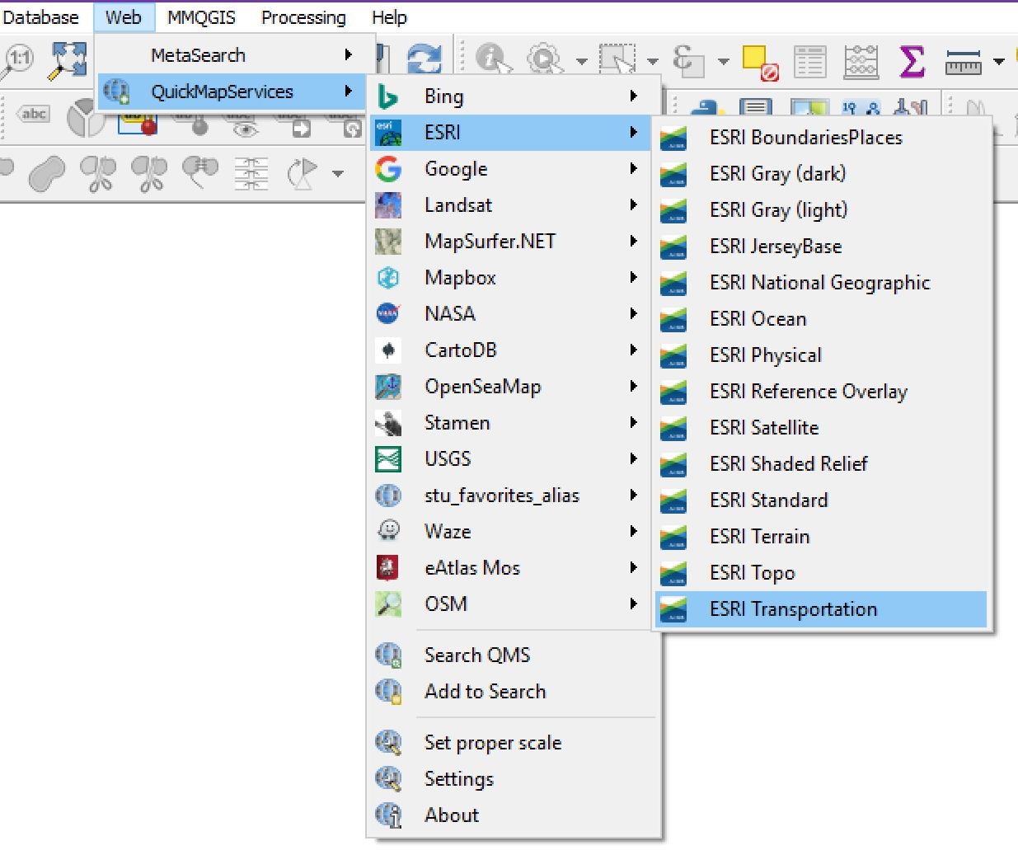

b. Once installed, it is accessed from QGIS > Web > QuickMapServices

c. The default installation lacks a number of useful basemaps, but many more can be added by going to the plugin's settings > More Services > Get contributed pack.

d. You can customize the basemap list by going to Settings > Visibility

e. Layer blending available!

f. I was unable to save as a local layer.

g. Supposedly you can add additional basemaps by Settings > Add\Edit\Remove
- I had trouble getting this to work. I also tried thru their website. Can PSQGIS folks solve?
- Two potential candidates for adding to QMS:
- USGS NGS Topo quads
- ESRI World Hillshade
- Here are their service urls:

http://server.arcgisonline.com/arcgis/rest/services/USA_Topo_Maps/MapServer http://server.arcgisonline.com/arcgis/rest/services/Elevation/World_Hillshade/MapServer

h. QMS Resources:

http://nextgis.com/blog/quickmapservices

https://github.com/nextgis/quickmapservices

https://github.com/nextgis/quickmapservices/wiki/Adding-data-source

https://translate.google.com/translate?sl=ru&tl=en&js=y&prev=_t&hl=ru&ie=UTF-8&u=http%3A%2F%2Fgis-lab.info%2Fqa%2Fquickmapservices.html&edit-text=

3. ArcGisFeatureServer
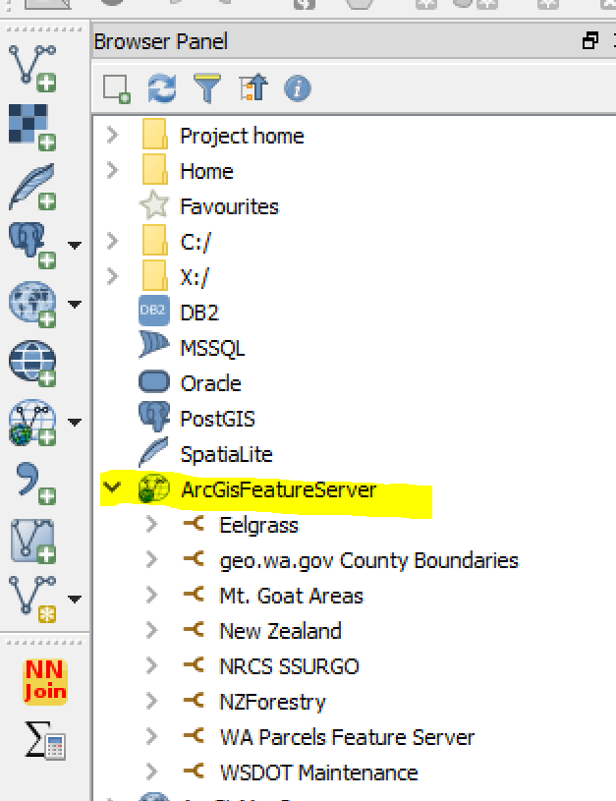

You get an attribute table!

Once downloaded, save it to a local layer!

Layer blending!

Examples:

1. https://gis.wcrc.govt.nz/arcgis/rest/services/Environment/AirManagementZones/MapServer

2. geo.wa.gov > Transportation > Maintenance Data Landscaped Areas > APIs > GeoService
- Ctrl-C
- In QGIS > Browser Panel > ArcGisFeatureServer > (r-click) New Connection and Ctrl-V the url from above, EXCEPT delete anything to the right of .../MapServer
- r-click and Add Layer

HOWEVER, sometimes it doesn't work:

geo.wa.gov > Boundaries > County Boundaries, Washington
- Error pops up when trying to load the layer into the map.
- This url ends in …/FeatureServer instead of …/MapServer
- Does that make a difference?
- Or maybe a provider error?
- Or...?
4. ArcGisMapServer

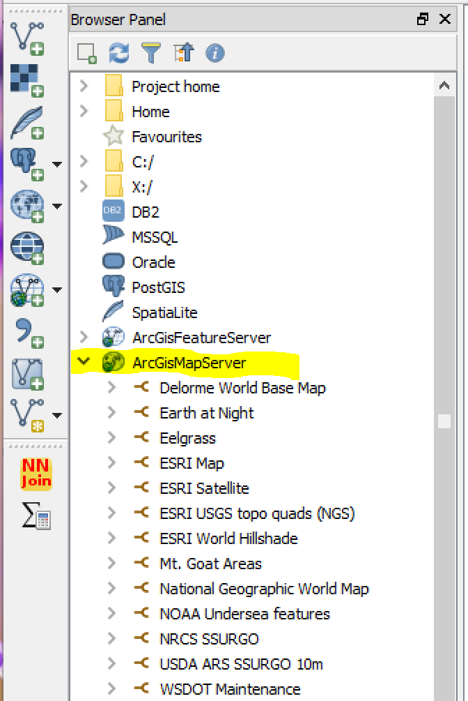
No attribute table.

I was unable to save as a local layer

Layer blending!

Two data sources that I'm aware of:

1. https://server.arcgisonline.com/ArcGIS/rest/services
a. Click on a service.
b. Copy the url from the browser's address bar
- the url typically takes the form of :
https://server.arcgisonline.com/arcgis/rest/services/mapname/MapServer
c. QGIS > Browser Panel > ArcGisMapServer > R-click and paste the url into the URL bar.
d. Add a name of your choice.
4. ArcGisMapServer, continued

2. Arcgisonline.com
a. Gallery > ESRI Featured Content Details > click on a layer > Details
- for example, Delorme World Basemap
b. Towards the bottom left of this page, under the “Layers” section, click the layer name (in this case Delorme_World_Base_Map). This opens up the ArcGIS REST Services Directory web page.
c. From the web page window, copy the url, which begins in https://... and ends in .../MapServer
d. QGIS: Browser Panel > R-click ArcGisMapServer and paste the url from above in the New Connection. Supply a name and ok.
e. Within the Browser Panel, drop down and r-click the newly added basemap and select Add Layer.
f. Voila! The basemap displays in the Layers Panel.

Here's an Arcgisonline layer that was posted by a non-ESRI individual:
- Gallery > ESRI Featured Content > Earth at Night > Details > a new web page appears
- Click the link Earth at Night (2016) > another web page opens
- Click the link Black Marble 2016 (500m) > another web page opens > copy the URL
- QGIS: Browser Panel > R-click ArcGisMapServer > paste URL
- Important! Delete any text following "...MapServer", such as "/0". The result:
https://tiles.arcgis.com/tiles/P3ePLMYs2RVChkJx/arcgis/rest/services/Earth_at_Night_2016/MapServer

Resources:

https://gis.stackexchange.com/questions/202615/adding-arcgis-online-services-to-qgis
- see the section under 2.18
http://geobern.blogspot.ca/2017/03/using-geonb-map-services-in-qgis.html
http://www.geodose.com/2017/08/how-to-use-arcgis-rest-api-service-qgis.html

Questions:
- I don't know how ArcGisMapServer is different than Tile Server (XYZ) or WMS
5. Native support using the Browser Panel Tile Server (XYZ):

a. I believe this is equivalent to the pre-2.18 WMTS option

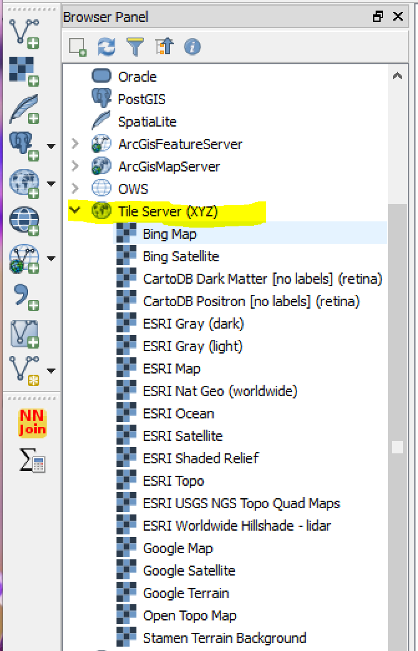
b. Supposedly bigger/better/faster and able to zoom in further than the other methods.
- Tiles display as they download, rather than the screen remaining blank until all tiles arrive
- However, QuickMapServices also seems to display tiles as they download.
- The ability to manually enter layers.
- However, QuickMapServices is supposed to be able to do this as well (see QMS above)
- So I'm not totally sure that this “Native Support” is an improvement over QMS
- Except! I was able to install USGS NGS Topo Quads and ESRI World Hillshade (below)

c. The basemaps are installed in the Browser Panel (View > Panels > Browser Panel)
- R-click Tile Server (XYS) for a New Connection
- Enter an “XYZ tile layer URL”
- In the form of http://c.tile.openstreetmap.org/{z}/{x}/{y}.png
- Then add a descriptive name. It is now listed under Tile Server (XYZ)

d. To display the layer, double-click its name
- Voila! The layer now displays, and is listed in the Layers Panel.

e. Layer blending is available!

f. I was unable to save as a layer file.

5. Native support using the Browser Panel Tile Server (XYZ), continued:

d. Here are the layers that I have added to Tile Server (XYZ):

Bing:

Map:
http://ecn.dynamic.t0.tiles.virtualearth.net/comp/CompositionHandler/{q}?mkt=en-us&it=G,VE,BX,L,LA&shading=hill

Satellite:
http://ecn.t3.tiles.virtualearth.net/tiles/a{q}.jpeg?g=0&dir=dir_n' yOrigin: Top (yOriginTop=1)

CartoDB:

Dark Matter [no labels] (retina):
http://a.basemaps.cartocdn.com/dark_nolabels/{z}/{x}/{y}@2x.png

Positron [no labels] (retina):
http://a.basemaps.cartocdn.com/light_nolabels/{z}/{x}/{y}@2x.png

ESRI:
Note that the ESRI addresses begin with either:

http://server.arcgisonline.com/
or
https://services.arcgisonline.com/

What the heck is the difference between these two addresses? Both results look the same!

Gray (dark):
http://services.arcgisonline.com/ArcGIS/rest/services/Canvas/World_Dark_Gray_Base/MapServer/tile/{z}/{y}/{x}

Gray (light):
http://services.arcgisonline.com/ArcGIS/rest/services/Canvas/World_Light_Gray_Base/MapServer/tile/{z}/{y}/{x}

Map:
https://server.arcgisonline.com/ArcGIS/rest/services/World_Street_Map/MapServer/tile/{z}/{y}/{x}

National Geographic (worldwide):
http://services.arcgisonline.com/ArcGIS/rest/services/NatGeo_World_Map/MapServer/tile/{z}/{y}/{x}
5. Native support using the Browser Panel Tile Server (XYZ), continued:

Ocean:
https://services.arcgisonline.com/ArcGIS/rest/services/Ocean/World_Ocean_Base/MapServer/tile/{z}/{y}/{x}

Satellite:
https://server.arcgisonline.com/ArcGIS/rest/services/World_Imagery/MapServer/tile/{z}/{y}/{x}

Shaded Relief:
https://server.arcgisonline.com/ArcGIS/rest/services/World_Shaded_Relief/MapServer/tile/{z}/{y}/{x}

Topo:
http://services.arcgisonline.com/ArcGIS/rest/services/World_Topo_Map/MapServer/tile/{z}/{y}/{x}

USGS NGS Topo Quad Maps:
https://server.arcgisonline.com/ArcGIS/rest/services/USA_Topo_Maps/MapServer/tile/{z}/{y}/{x}

Worldwide Hillshade – lidar:
https://server.arcgisonline.com/ArcGIS/rest/services/Elevation/World_Hillshade/MapServer/tile/{z}/{y}/{x}

Google:

Map:
https://mt1.google.com/vt/lyrs=m&x={x}&y={y}&z={z}

Satellite:
https://mt1.google.com/vt/lyrs=s&x={x}&y={y}&z={z}

Terrain:
https://mt1.google.com/vt/lyrs=p&x={x}&y={y}&z={z}

Open Maps:

Topo:
https://a.tile.opentopomap.org/{z}/{x}/{y}.png

Stamen:

Terrain Background:
http://a.tile.stamen.com/terrain-background/{z}/{x}/{y}.png

5. Native support using the Browser Panel Tile Server (XYZ), continued:

e. Where did I get these basemap locations?
Two main sources:
1. QuickMapServices:
- Load a basemap from QMS
- Properties > General > Layer source > select and copy text from "http... to ....png"
- For example: https://a.tile.opentopomap.org/{z}/{x}/{y}.png
2. Arcgisonline:
- Go to https://server.arcgisonline.com/ArcGIS/rest/services
- Click on a service
- Copy the url from the browser's address bar
- the url typically takes the form of :
https://server.arcgisonline.com/arcgis/rest/services/mapname/MapServer
- QGIS > Browser Panel > ArcGisMapServer > R-click and paste the url into the URL bar.
- Add the following text string to the end of the url from above: /tile/{z}/{y}/{x}.png
- Add a name of your choice.

f. What's the difference between Tile Server (XYZ) and QuickMapServices?
- They appear to be identical in many ways:
- similar display speed
- ability to work with various projections
- layer blending
- But Tile Server (XYZ) has an advantage in that you are not reliant on the plugin developer. Plus you can add your own layers of interest. For example, I have been unable to add my beloved USGS NGS Topo Quad Maps and Worldwide Hillshade to Quickmaps. However, I was able to add them to Tile Server (XYZ) using the steps above.

g. What I don't know:
- Some Tile Server (XYZ) addresses do not follow the "url/tile/{z}/{y}/{x}.png" format, such as the Bing Map and Satellite. So what is the standard format, if any?

h. Tile Server (XYZ) resources:

https://www.lutraconsulting.co.uk/blog/2016/10/26/qgis-xyz-tile-wmts-preview/

https://www.youtube.com/watch?v=8HhGwfA7M50

6. WMS
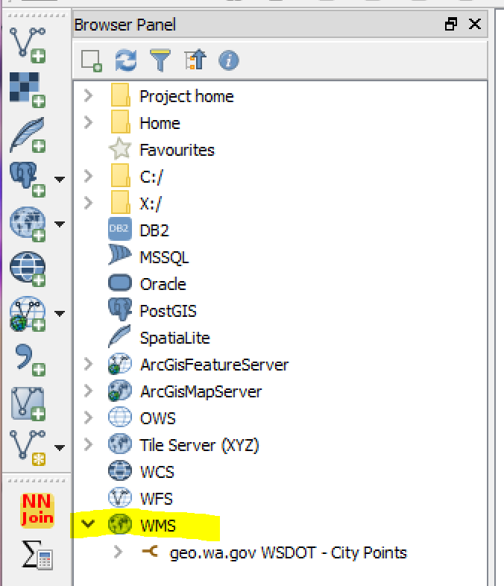

No attribute table (maybe, see below)

I was unable to save as a local layer

Layer blending!

I did not investigate much. However, I did notice that some geo.wa.gov pages did offer WMS as an option. For example:

http://geo.wa.gov/datasets/WSDOT::wsdot-city-points > APIs

- From APIs, copy the OGC WMS option
- QGIS > Browser Panel > R-click > New Connection > paste URL, then add a name
- Drop-down the newly added WMS layer and select the desired layer.

- Curiously, you can get a feature from WMS (I thought that WMS was map only, not feature):
- For example: WMS > geo.wa.gov WSDOT – City Points> City Points > Lines
- An attribute table is available!!!
- But wait, I tried this later, but no Lines and the associated attributes. What???

7. More questions...

a. I did not have time to investigate:
- OWS
- WCS (I think this is for serving images)
- WFS

What is the difference between WMS and ArcGisMapServer?

b. What is the difference between WFS and ArcGisFeatureServer?

c. How to distinguish between a feature server url and a map server url just by looking at their text?

d. Some services work both as Map and Feature, but some only work as a Map service OR a Feature service, not both:

- Here's an example that works as both Map and Feature services:
geo.wa.gov > Eelgrass:
https://gis.dnr.wa.gov/site3/rest/services/Public_Aquatics/WADNR_PUBLIC_AQR_NS_HBTT/MapServer

- Here's an example that works only as a Map service:
https://server.arcgisonline.com/ArcGIS/rest/services/World_Street_Map/MapServer

- How do you tell the difference???

e. Some ArcGisFeatureServer don't work, even though the URLs look fine:

geo.wa.gov > County Boundaries:

https://services.arcgis.com/jsIt88o09Q0r1j8h/arcgis/rest/services/StateBoundary/FeatureServer

- Note that the layer properties ends with /0 while it's parent does not have that text string. Is this important?

f. What's with this API key stuff?
- QMS > OSM > OSM Cycle Map
- When loaded, the watermark "API Required" appears

8. Is there a clearinghouse for basemaps (feature server and map server)?

- Yes!

From: CPS-GIS [mailto:cps-gis-bounces@mailman13.u.washington.edu] On Behalf Of Joseph Elfelt
Sent: Wednesday, January 17, 2018 9:23 AM
To: cps-gis@u.washington.edu<mailto:cps-gis@u.washington.edu>
Subject: [Cps-gis] List of ArcGIS servers with open data - federal and state

Below are links to PDFs I made with a list of federal and state ArcGIS servers with open data. By open data I mean that no login credentials are required.

Want to help make the lists better?

If so, please send me the 'top' endpoint for any federal or state ArcGIS server that is not yet listed and which has at least some open data. Anytime I tweak either list I will post the updated list the next morning. The title on each list includes the date last updated.

And if you know about a similar list that anyone has assembled please point me in their direction so we can compare notes.

50+ federal ArcGIS servers
https://mappingsupport.com/p/surf_gis/list-federal-GIS-servers.pdf

150+ state ArcGIS servers
https://mappingsupport.com/p/surf_gis/list-state-GIS-servers.pdf

Joseph Elfelt
Redmond, WA
https://mappingsupport.com
https://www.facebook.com/Gmap4/
Twitter @mappingsupport

