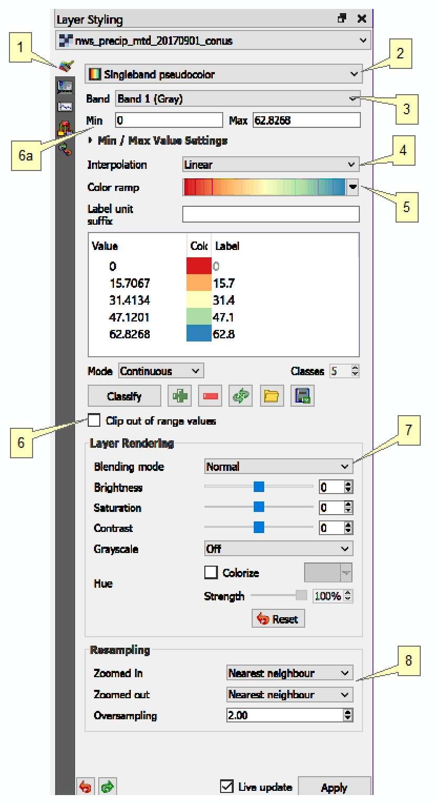
A. What are color ramps?
- https://en.wikipedia.org/wiki/Color_gradient

B. How to access the default QGIS color ramps:

QGIS installs with 590 (!) color ramps.

1. Highlight a layer's name in the Table of Contents
2. Press the F7 button, which opens the Layer Styling pane:
3. From the Layer Styling pane, click the Symbology button (the paintbrush icon) [1]:
4. Select the Singleband Pseudocolor dropdown [2]
5. From the Band dropdown, select Band 1 [3]
6. From the Interpolation dropdown, select Linear [4]
7. From the Color Ramp dropdown, select your color ramp choice [5]
a) A few suggested color ramps are now shown [5a]
b) To see additional color ramps:
i. Select "All Color Ramps" [5b]
ii. About 35 color ramps are now displayed for selection [5c]. However, these are just a few of the 590 available, so it is puzzling that this choice is titled "All".
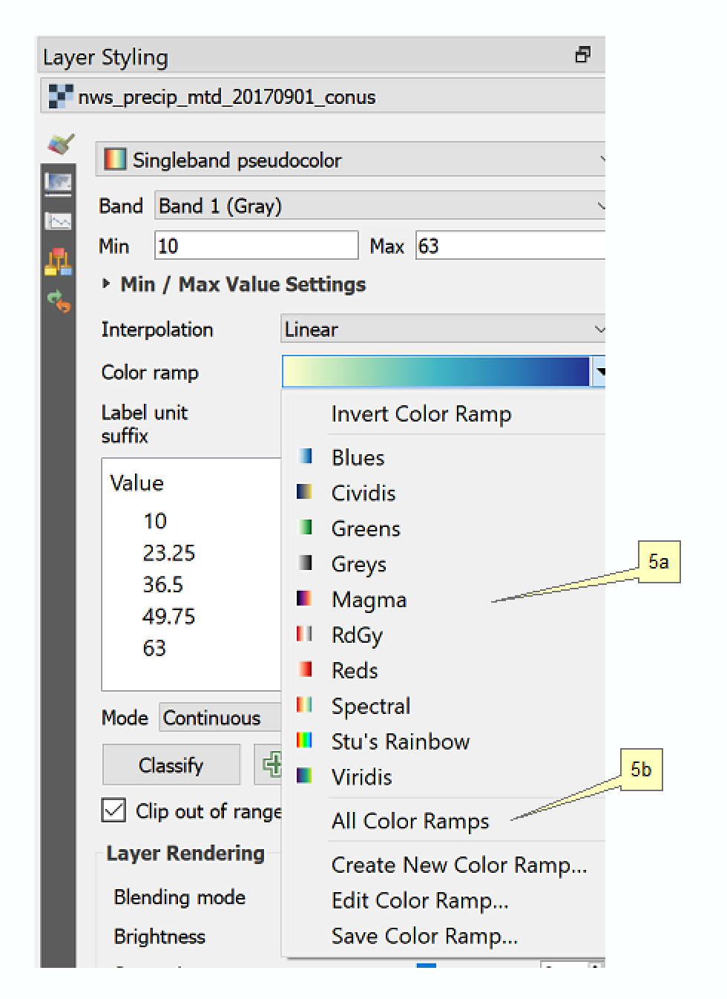
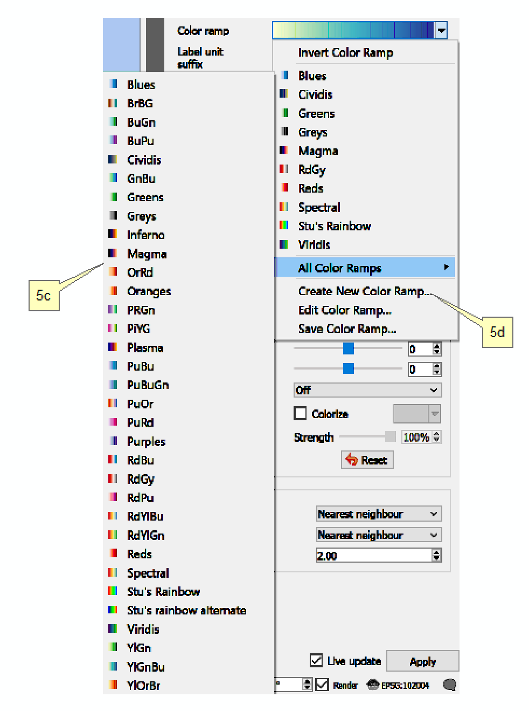
b) To see all of the 590 color ramps:
i. Select "Create New Color Ramp..." [5d]
ii. Select the dropdown "Catalog: cpt-city" (not sure what cpt-city refers to...) [5e]
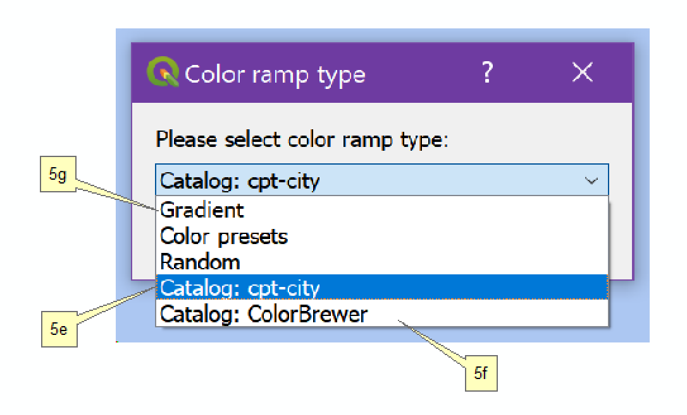
- Voila! You can browse through all 590, or view them organized by theme, such as Topography:

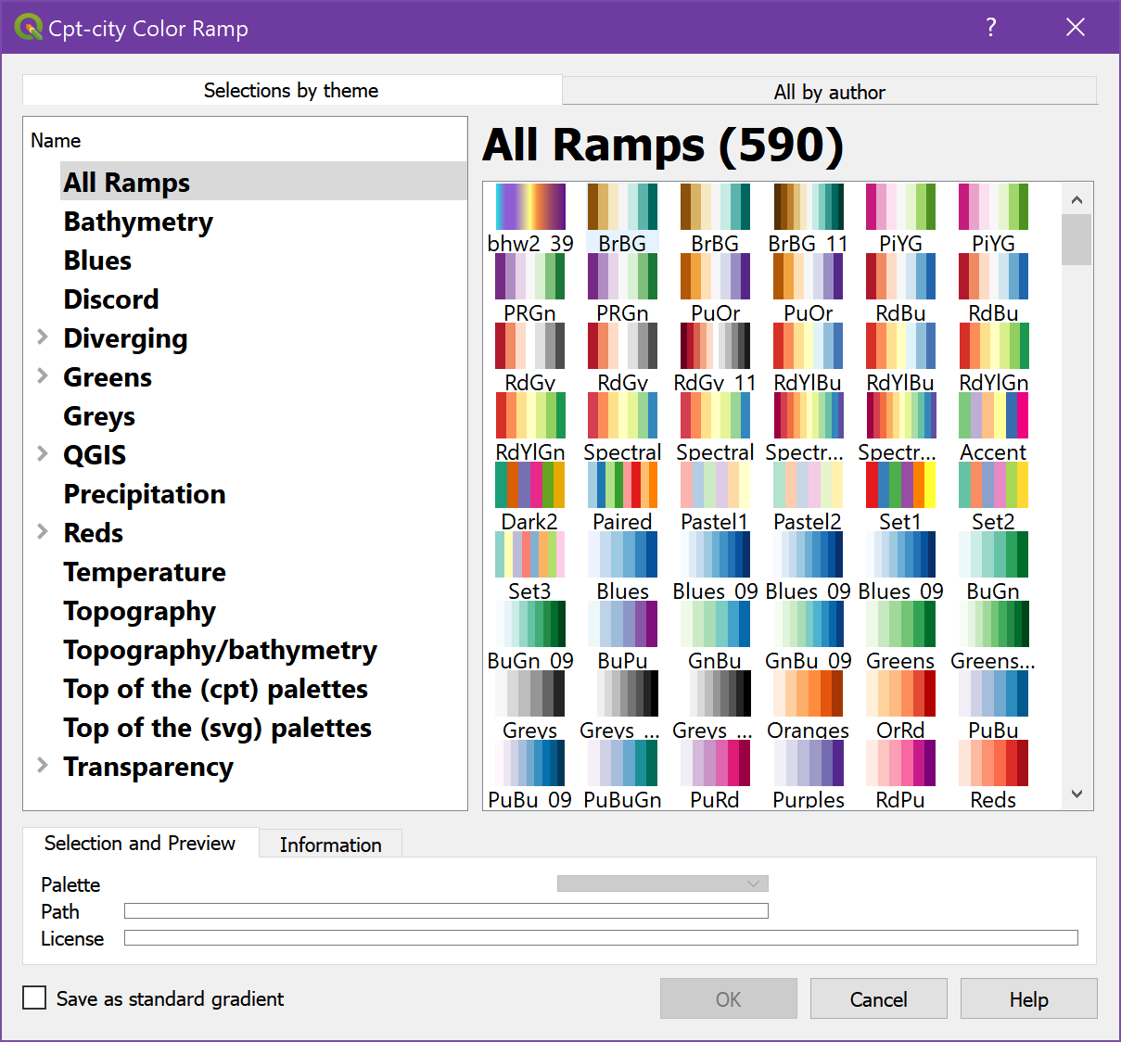
iv. Alternatively, to see just the Color Brewer (colorbrewer2.org) ramps, select the dropdown "Catalog: ColorBrewer" [5f]

8. To paint just a range of values, click on the checkbox "Clip out of range values" [6] and then select the lower and/or upper range of values [6a]. Only values between the lower and upper values will be displayed. Values outside this range will be transparent.

9. If you want to display the raster layer in conjunction with another layer, such as a basemap, drop down the Blending Mode [7] and select "Multiply". This provides a much improved blending than simply setting the raster's transparency.

10. If the raster contains continuous data, such as a DEM, make sure that the "Resampling" settings [8] are not "Nearest neighbor". Bilinear and Average are suitable choices.
C. But Wait! There are yet more color ramps available!

This web site contains a list of additional color ramps:

http://soliton.vm.bytemark.co.uk/pub/cpt-city/

Here's an alternate view of the same ramps:

http://docs.idldev.com/vis/color/cptcity_catalog.html

Note the ESRI and ColorBrewer sections!

How do we access the color ramps from this web site?

1. Install the QGIS plugin: SVG2ColoR
- for info see https://cbsuygulama.wordpress.com/2014/06/26/svg2color-qgis-color-ramp-plugin/
2. Plugins > SVG2ColoR
- The SVG2ColoR window opens:

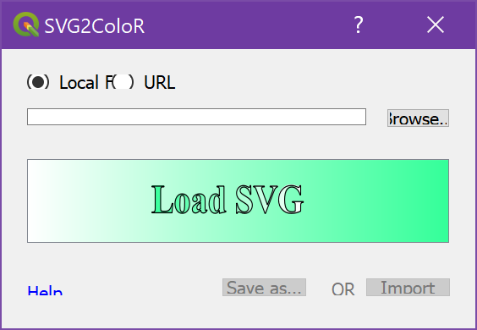

3. Now open a browser and navigate to: http://soliton.vm.bytemark.co.uk/pub/cpt-city/
- click on a palette. Keep clicking on the icons until the browser window resembles this pane:

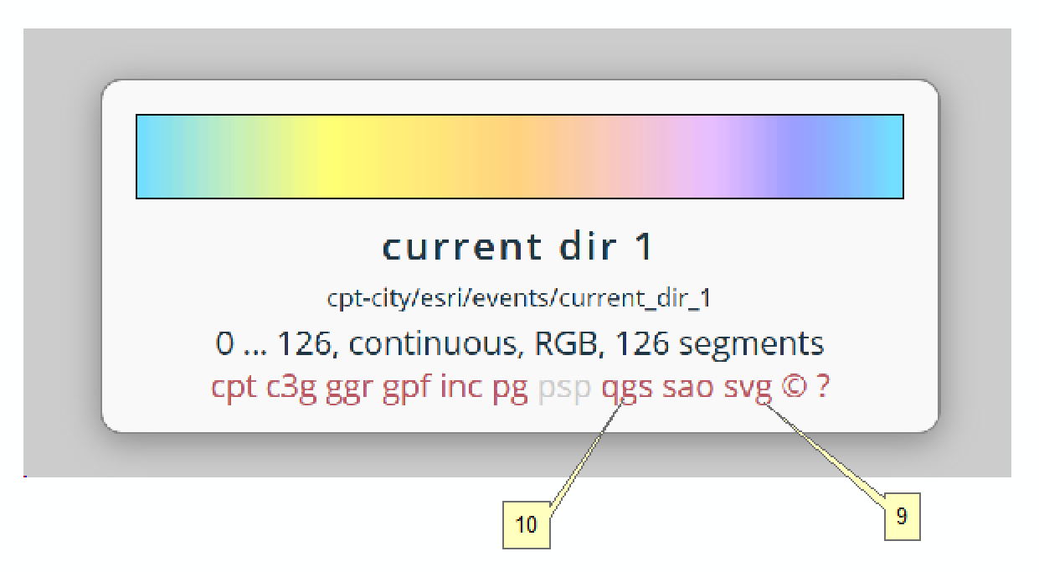

- in the palette's info box, right-click on "svg" [9] and select "Copy Link Location"
4. Back to the SVG2ColoR window.
- click the URL radio button
- paste the URL from the Copy Link Location above and click the Get URL... button.
- close the SVG2ColoR window
5. Open the DEM's Layer Properties window > Style
- In the Generate new color map section, drop-down and select the name of the color ramp that you just added.
- Click the Classify button
- Click ok
6. Note that it's possible to download the SVG file from the website above and save it to a local folder with the file extension *.svg
- and then load it into the SVG2ColoR window using the Local File radio button instead of accessing it from a URL
7. Supposedly you can download the color ramp directly without using SVG2ColoR by clicking on "qgs" [10], saving the file, then loading it directly via QGIS. But... the downloaded files are .qgs files. Shouldn't they be .qml??? I dunno...

D. If you still can't find a suitable color ramp, make your own!

1. Select "Create New Color Ramp..." [5d]
2. Select the dropdown "Catalog: Gradient" [5g]
- the "Select Color Ramp" window now appears:

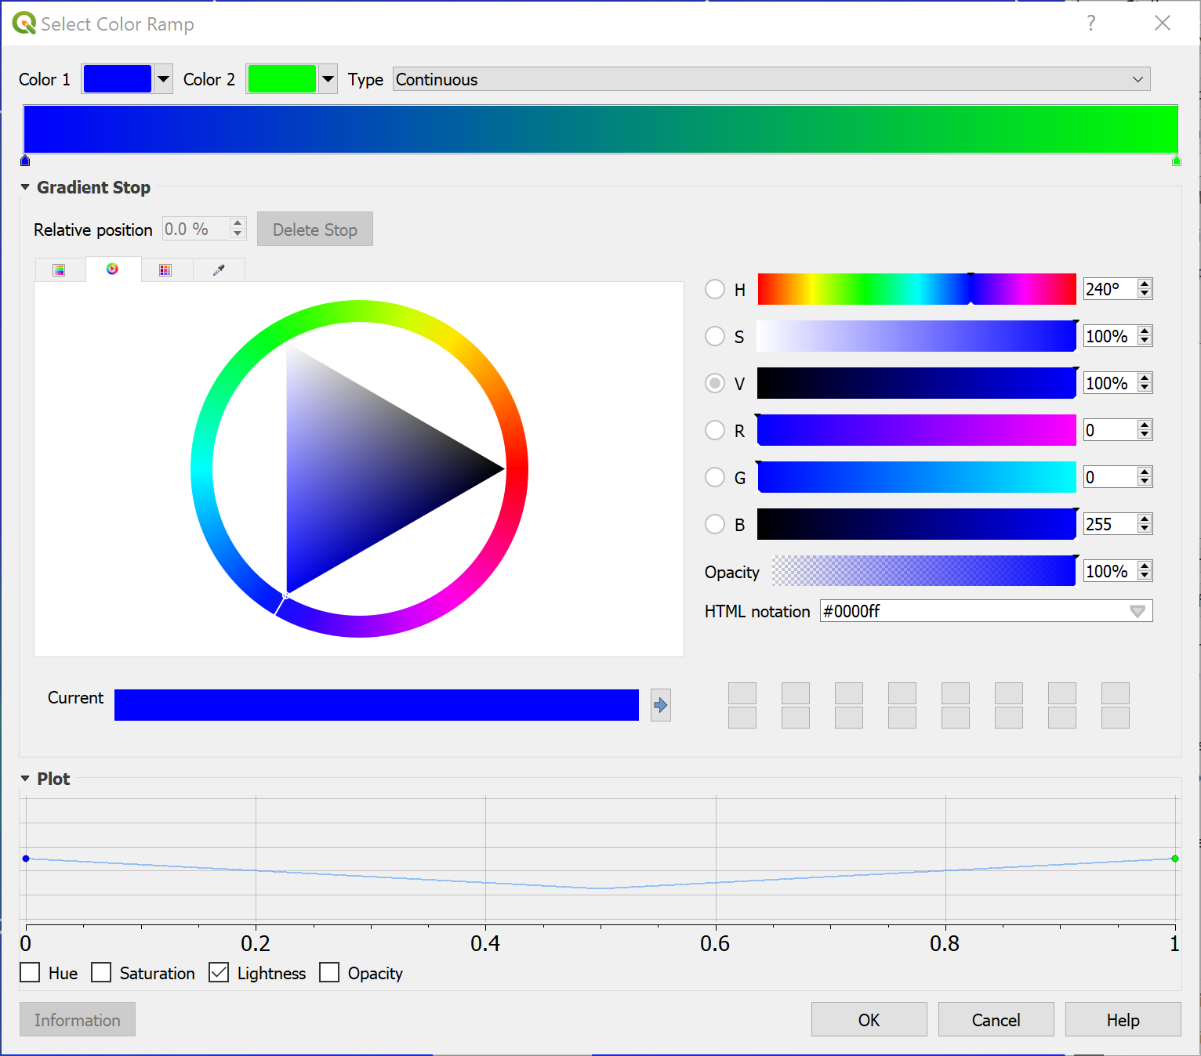
3. Making a custom color ramp is actually quite easy! Here's a link (with text and video) that describes how to do it:

http://opensourceoptions.com/qgis/2018/03/30/qgis3-custom-color-ramp.html

E. Here's the link to the precipitation data that accompanies this document:

https://water.weather.gov/precip/download.php
- Select GEOTIFF, month, August 2017
- Band info:
- Band 1 - Observed precipitation, in inches*
- Band 2 - Normal precipitation, in inches
- Band 3 - Departure from normal, in inches
- Band 4 - Percent of normal
This was subsequently reprojected to: USA_Contiguous_Lambert_Conformal_Conic, EPSG: 102004

* This is the band that we selected in step B5 above.

